Name: Abdelrahman Ismail Sallam

BN:11

Topic: Mobile Computing

**Mobile Computing-Brief Overview:**

Mobile computing is a technology that enables data, voice , and video to be transmitted through a computer or any other wireless device without having to be linked to a fixed physical link. The principal concept is Mobile communication,Mobile hardware ,Mobile software

**Mobile communication**

the mobile contact refers to the network that has been set up to ensure smooth and efficient communication continues. These would include the devices necessary to facilitate and support the services, such as protocols, services, bandwidth and portals. At this stage , the data format is defined too. This ensures that there is no collision with other existing systems offering the same service. The overlaying infrastructure is basically radio wave-oriented, since the media is unguided / unbounded. That is to say, the signals are transported over the air to intended devices capable of receiving and transmitting similar signals

1. Mobile and Wired : In this configuration, Some of the devices are wired and some are mobile in nature. For Example : Laptops.
2. Fixed and Wired : In this configuration, The devices are fixed at a position and are connected through a physical link for communication. For Example : Office/Desktop Computer.
3. Mobile and Wireless : In this configuration, devices can communicate(data transmission) with each other irrespective of their position and can connect to any network without the use of any wired device. For Example : WiFi Dongle.

### Soft ware

Mobile software is the actual program that runs on the mobile hardware. It deals with the functionality and specifications of mobile devices. This is the Mobile Device Engine. In other words, it is the Appliance's operating system. It is the essential component that operates the mobile device. Because portability is the main factor, this type of computing ensures that users are not attached to a single physical location, but are able to operate from anywhere. It embodies all aspects of wireless communication

### Hard ware

Mobile hardware includes components for mobile devices or devices which receive or access mobility service. They will range from laptops , smartphones, tablet computers, personal digital assistants. Such instruments should have a medium with a receptor capable of detecting and receiving signals. These devices are configured to operate in full duplex, thus being able to simultaneously send and receive signals. They don't have to wait until one device communicates to the other device to start communications .

**Mobile Computing-advantages:**

Location Flexibility

This has allowed users to work from anywhere, as long as a connection has been created. A user may work without having to be in a fixed position. Their mobility ensures they can perform numerous tasks simultaneously and perform their stated jobs

Saves Time

When commuting from various places or to the workplace and back, the time spent or lost has been cut. One can now access all the important documents and files through a secure channel or portal, and work as though they were on their computer. In many companies, it's enhanced telecommuting. It has also brought down unnecessary expenses incurred.

Enhanced Productivity

Users can work efficiently and effectively from whichever location they find comfortable. This in turn enhances their productivity level.

Streamlining of Business Processes

Business processes can now be easily accessed via secured connections. Looking at security concerns, appropriate steps have been placed in place to ensure that the user using the services is authenticated and approved. Some business functions may be run over secure links and there may also be sharing of information between business partners. Video and voice conferencing can be used to conduct meetings , conferences and other informative services. Travel time and expenses are also reduced considerably

Entertainment

The video and audio recordings can now be streamed using mobile computing. A wide variety of films, educational, and informative material is easy to access. With the enhancement and availability at reasonable cost of high speed broadband connections, one is able to get all the entertainment they want while they browse the internet for streaming data. One can watch news, movies, and documentaries through the internet, among other entertainment offerings. This was not possible until mobile devices in the computer world dawned

Ease of Research

Work was made harder because users had to go to the field to dig for evidence to feed them back into the program sooner. It has also enabled the collection and feeding of data from wherever they are without making unnecessary trips to and from the office to the field

**Mobile Computing-Services:**

1. Short Message Service (SMS) A service that supports the sending and receiving of short text messages on mobile phones
2. Enhanced Messaging Service (EMS) An extension of SMS that can send simple animation, tiny pictures, sounds, and formatted text
3. Multimedia Messaging Service (MMS) The emerging generation of wireless messaging; MMS is able to deliver rich media
4. E-payments Electronic payments for purchase amounts.
5. Location-based services
6. global positioning system (GPS) A worldwide satellite-based tracking system that enables users to determine their position anywhere on the earth
7. Voice-support services
8. interactive voice response (IVR) A voice system that enables users to request and receive information and to enter and change data through a telephone to a computerized system
9. voice portal A Web site with an audio interface that can be accessed through a telephone call
10. personal area network (PAN) A wireless telecommunications network for device-to-device connections within a very short range
11. Bluetooth A set of telecommunications standards that enables wireless devices to communicate with each other over short distances
12. Wireless Local Area Networks and Wi-fi
13. wireless local area network (WLAN) A telecommunications network that enables users to make shortrange wireless connections to the Internet or another network
14. Wi-Fi (wireless fidelity) The common name used to describe the IEEE 802.11 standard used on most WLANs
15. wireless access point An antenna that connects a mobile device to a wired LAN
16. hotspot An area or point where a wireless device can make a connection to a wireless local area network (using Wi-Fi)

screenshots:

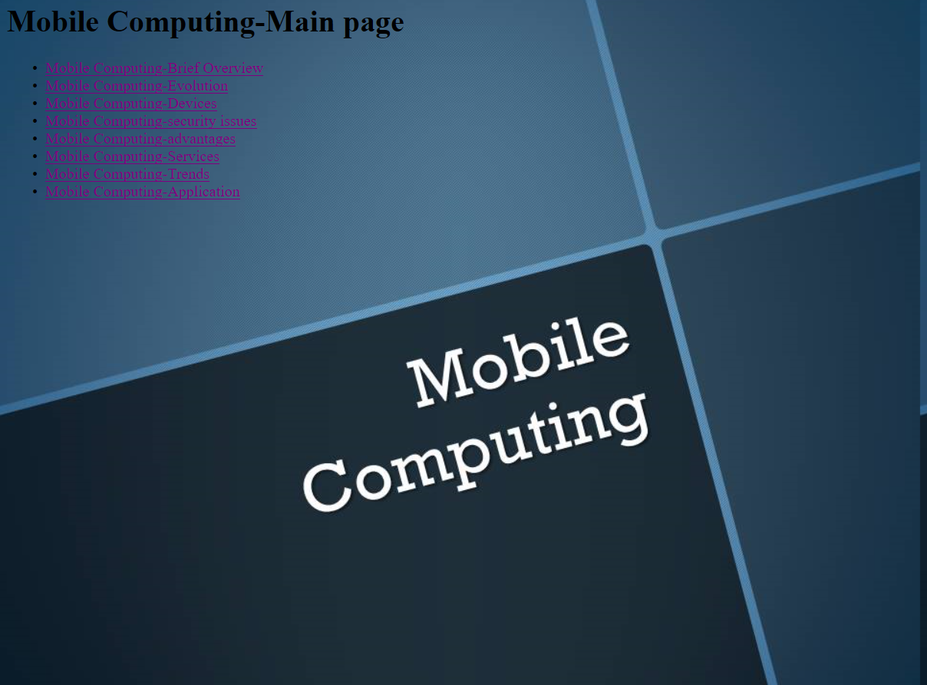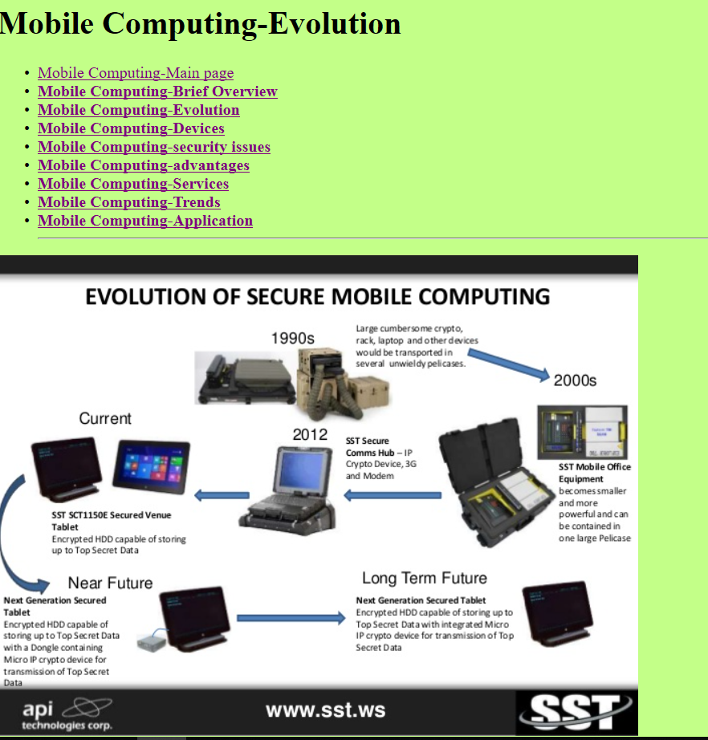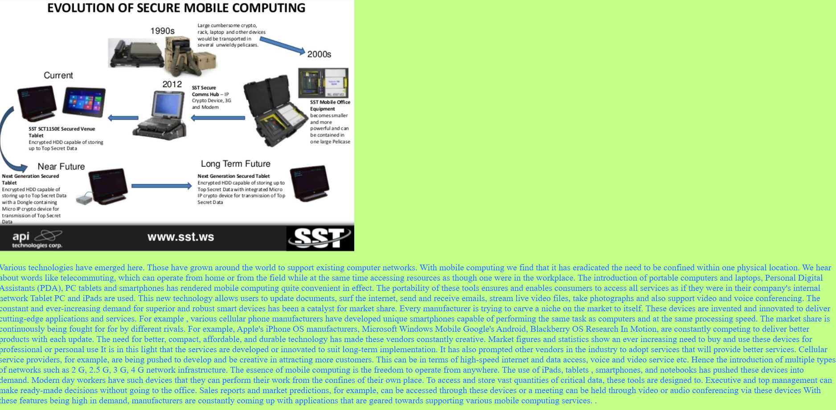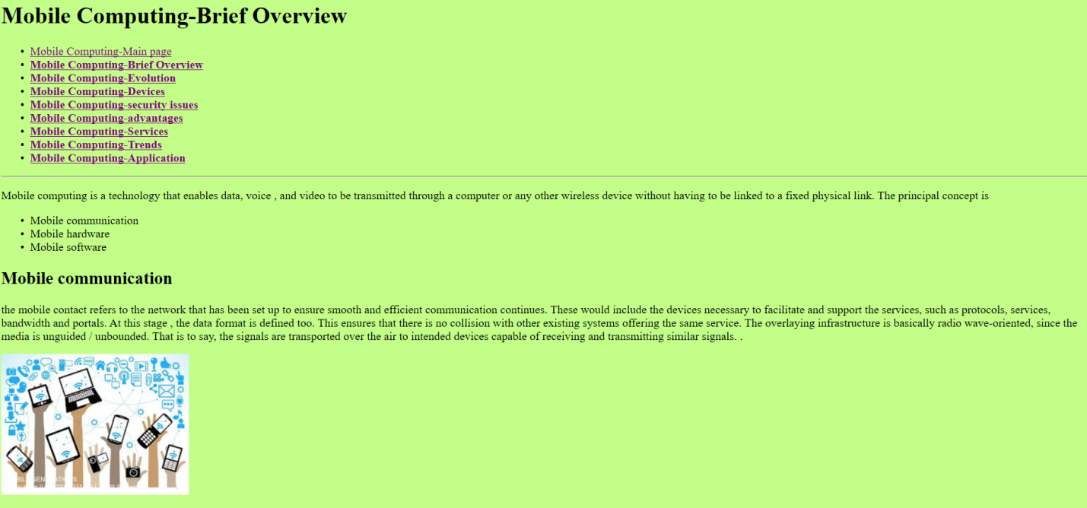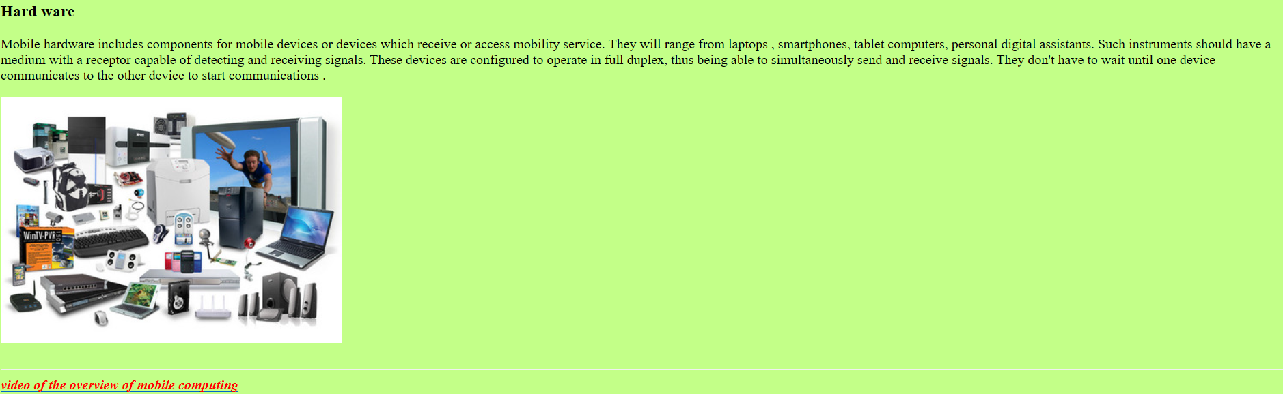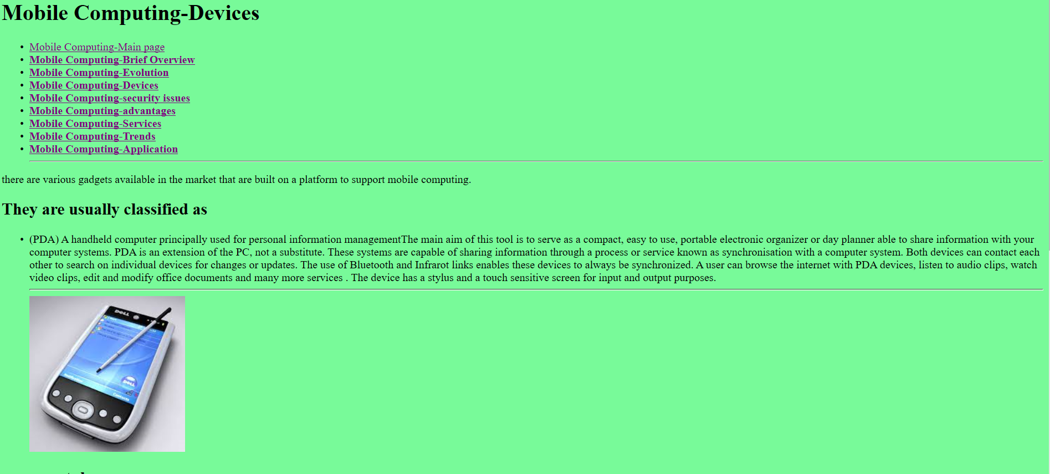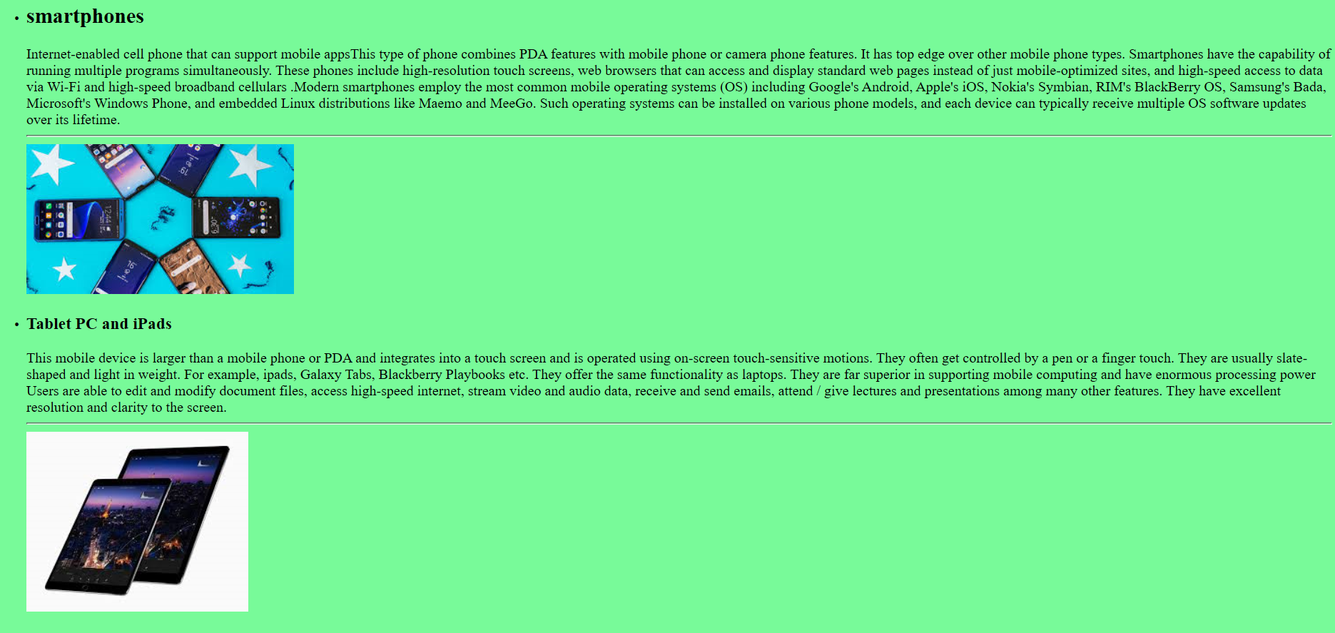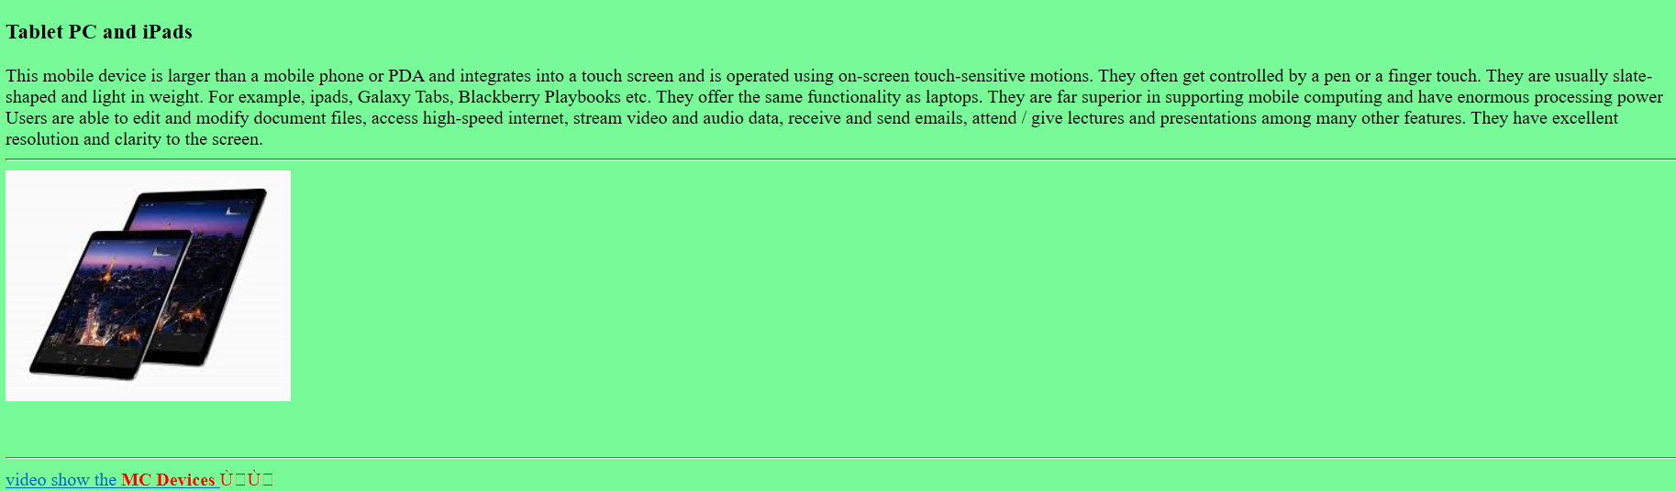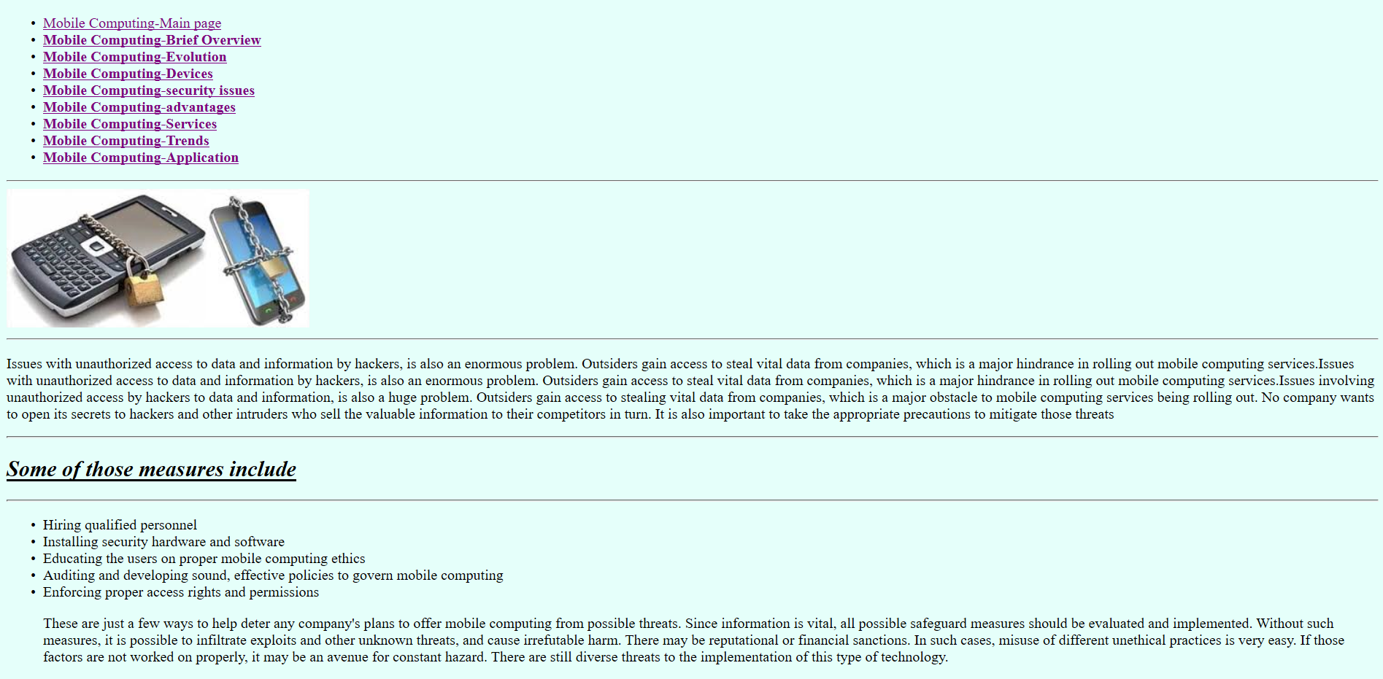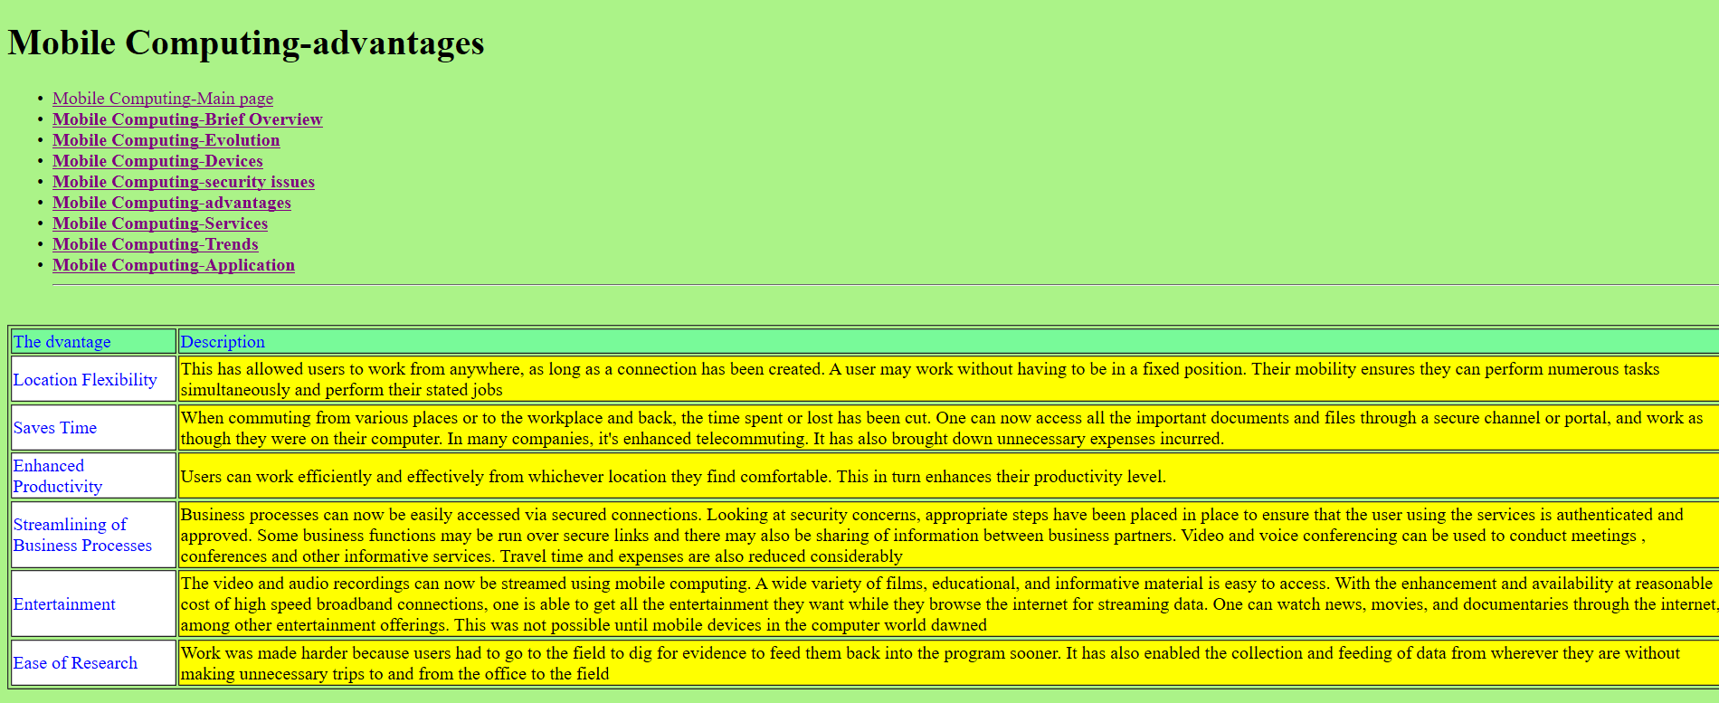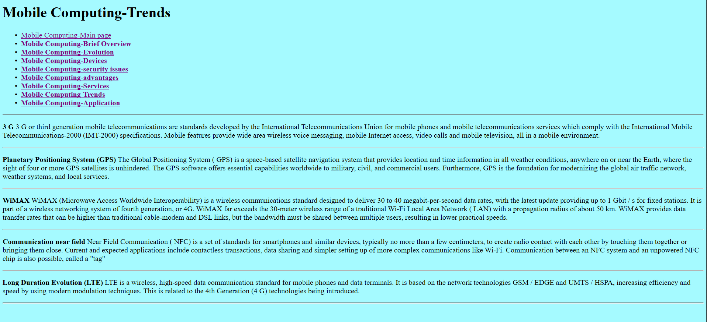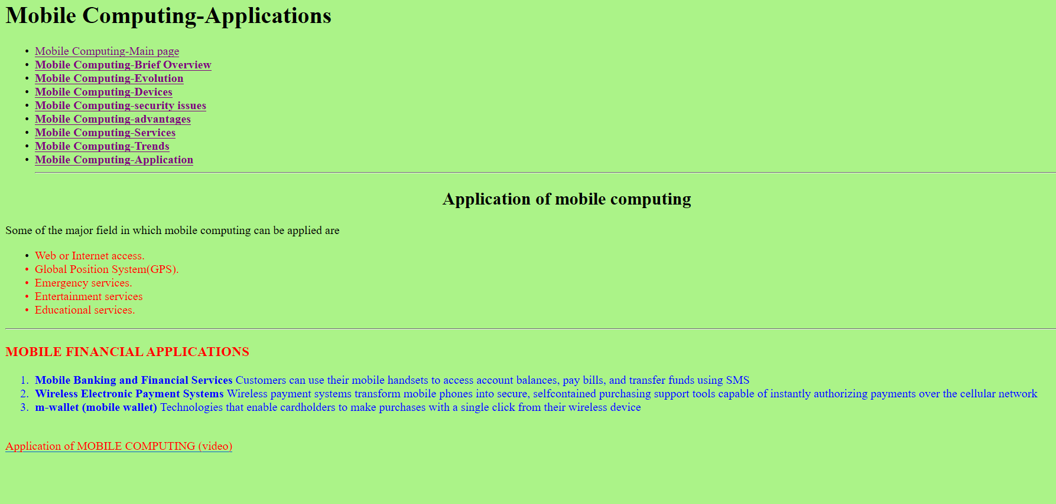

Code source:

